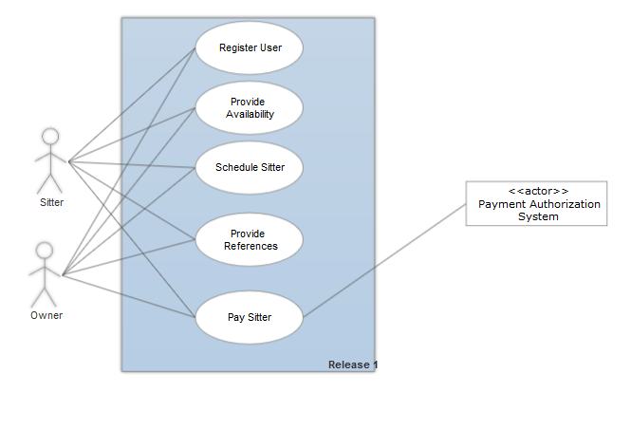

Register User: The user selects the register option. The system then prompts the user for information about themselves such as how old they are and what kind of pets they will to sit for. Once the user enters all of the information, the system will verify and save it.

Provide Availability: The user opens their personal calendar and logs their available times for sitting. The system then verifies these logs and the changes are saved to the user’s profile.

Schedule Sitter: The owner selects the desired time period to have their pet watched and the urgency of the situation. The system then displays matched users. The owner browses the matched sitters and selects the one that they feel best fits. The chosen sitter then gets a notification from the system. The sitter accepts the task and the appointment is logged on both accounts.

Provide Preferences: The user opens their profile and logs their pet preferences. The system verifies this information and then saves the changes.

Pay sitter: The owner reviews the bill and the system prompts for a tip. The owner enters the desired tip and confirms the payment. The system verifies the payment with a third party authentication service and it is sent to the sitter’s account, along with a notification.